**1.Assignement**

1.Install a Docker using VM

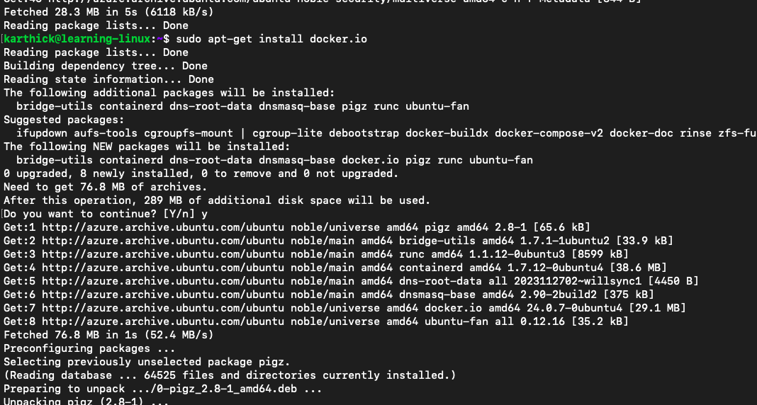

1. Pull hshar/webapp (https://hub.docker.com/r/hshar/webapp) repository 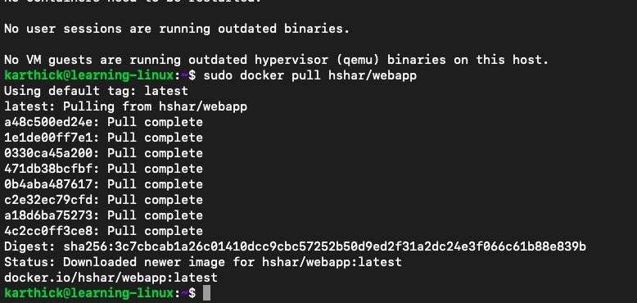
2. Create a new file in this repository 